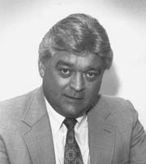

**Monday, June 25, 2018**

**The Woodlands Golf Course**

$125 per person or $500 per foursome

8:00 AM Registration, Coffee and Donuts

9:00 AM Shotgun Start

Captain’s Choice Format

*Proper Golf Attire Required/ Soft Spikes*

*MICHAEL J. WAGNER, SR.*

*MEMORIAL*

*Greater Ferndale Open*

For Info Contact Jim McHugh (443-618-8234)

Email – [TRGFERNDALE1@aol.com](mailto:TRGFERNDALE1@aol.com)

Fax – 410-760-6204

Make Checks Payable to:

**The Friends of Ferndale, Inc.**

Mail entry forms and checks to:

**7217 Baltimore Annapolis Blvd.,**

**Ferndale, MD. 21061**

**TEE SPONSORSHIP $100**

**Sign to read**:

**NAMES OF GOLFERS**

1) 2)

3) 4)

Contact: Email:

**GOLF PACKAGE INCLUDES**

• Green fees and cart

• Beverages on the course

• Continental Breakfast/Box Lunch/Buffet

• Prizes for 1st, 2nd, and 3rd Place

• Longest Drive (Men’s & Ladies)

• Closest to the Pin (Men’s & Ladies)